BRIDGING AMATEUR METEOROLOGY AND HURRICANE MONITORING: A PORTABLE WEATHER MONITORING SYSTEM FOR ISLAND COMMUNITIES

Emanuel-Sebastian CĂLIN

Constanța Maritime University

Coordinator: Lecturer PhD Alina Lucia BOȘTINĂ

Constanța Maritime University

Abstract

Hurricanes are extreme meteorological events with significant consequences for island communities, where geographical isolation, exposure to strong winds, and infrastructure vulnerability can intensify their social and operational impacts. In this context, real-time local weather monitoring can support preparedness, situational awareness, and emergency response. This study presents the design, implementation, and functional evaluation of a portable, low-cost meteorological monitoring system intended for hurricane-prone island environments. The prototype measures wind speed, temperature, relative humidity, and atmospheric pressure using a Hall sensor-based cup anemometer and an integrated AHT20 + BMP280 sensor module. The collected data are transmitted wirelessly to a central station and published online through the ThingSpeak platform, enabling remote access and visualisation. The system architecture, operating principles, and communication flow are described to show how localised meteorological data can be acquired and made available remotely. Functional tests confirmed the prototype's ability to collect, transmit, and publish meteorological data, indicating its potential as a complementary tool for local weather observation in areas exposed to severe weather events.
Keywords: hurricane-prone islands; disaster preparedness; portable weather station; low-cost meteorological instrumentation; remote data visualisation.

- Introduction

Tropical cyclones (TCs), referred to as hurricanes in the Atlantic and eastern North Pacific basins, are among the most destructive meteorological hazards, affecting millions of people worldwide each year (1, 2). In these basins, a tropical cyclone is classified as a hurricane when its maximum sustained winds reach at least 64 knots, equivalent to approximately 119 km/h or 74 mph (3). Hurricane intensity is commonly described using the Saffir-Simpson Hurricane Wind Scale, which relates wind-speed categories to the potential for property damage and infrastructure disruption (4). Beyond extreme winds, tropical cyclones are multi-hazard events that may produce torrential rainfall, storm surges, flooding, and occasionally tornadoes, generating complex impacts on natural and human systems (2).
Island areas are particularly exposed to the effects of hurricanes because geographical isolation, limited land area, and dependence on critical infrastructure can increase vulnerability. Ports, airports, coastal roads, electricity networks, and communication systems are essential for evacuation, emergency response, and recovery, but they may also be severely affected during extreme weather events. In small island contexts, damage to a limited number of critical assets can disrupt emergency coordination and post-event recovery (8, 9).
Meteorological observation is a key component of early warning systems. The World Meteorological Organization identifies detection, monitoring, analysis, and forecasting as essential elements of effective multi-hazard early warning, together with risk knowledge, warning dissemination, and preparedness to respond (5). At the global scale, observing systems support weather analyses, forecasts, advisories, warnings, and climate monitoring (6). However, in isolated or resource-limited island environments, local observations may be spatially sparse or difficult to maintain, especially during severe weather events.
The atmospheric parameters selected for monitoring in this study are directly relevant to hurricane-prone environments. Wind speed is one of the defining characteristics of hurricane intensity and is essential for evaluating hazardous wind conditions. Atmospheric pressure variations may indicate the approach or development of low-pressure weather systems, while temperature and relative humidity contribute to the characterisation of local atmospheric conditions. These variables are consistent with WMO guidance on meteorological observation, including air temperature, atmospheric pressure, humidity, surface wind, and automatic weather stations (7).
Recent developments in embedded systems, wireless communication, and Internet of Things technologies have enabled compact and affordable weather stations for real-time environmental monitoring. Such systems do not replace certified meteorological stations, but they can provide useful supplementary observations for educational, research, community-based, or temporary field applications (10). In this context, the term amateur meteorology refers to non-certified, community-oriented, and low-cost observation activities that can complement, but not replace, official meteorological infrastructure. In this context, amateur meteorology refers to non-certified, community-oriented, and low-cost observation activities that can complement, but not replace, official meteorological infrastructure.
The aim of this paper is to present and functionally evaluate a portable, low-cost meteorological monitoring system designed to complement local weather observations and support situational awareness in hurricane-prone island environments.

- Monitoring Needs in Hurricane-Prone Island Environments

Hurricane-prone island environments require monitoring approaches capable of providing timely, localised, and accessible meteorological information. The IPCC reports that small islands are increasingly affected by tropical cyclones, storm surges, heavy precipitation, sea-level rise, and related impacts across natural and human systems (8). Studies on Small Island Developing States also show that disaster vulnerability results from the interaction between physical exposure and local social, economic, and institutional conditions (9).
Although global and national observing networks provide indispensable information for forecasting and warning (5, 6, 7), local observations may be sparse in isolated or underserved areas, especially in small island contexts where exposure, remoteness, and infrastructure limitations increase vulnerability (8, 9). During severe weather events, permanent monitoring infrastructure may also be affected by power outages, communication disruptions, flooding, corrosion, or physical damage (5, 8, 9). Complementary local monitoring systems can therefore add practical value by increasing the number of observation points in vulnerable or underserved locations (5, 10).
For a local monitoring system to be useful, it should acquire relevant atmospheric variables and make them available to users without requiring direct access to the instrument. Wind speed, atmospheric pressure, temperature, and relative humidity provide a basic but important picture of the local atmospheric state and are among the standard variables considered in meteorological observation practice (7). Remote visualisation further supports situational awareness because users can observe changing conditions from a safer or more centralised location, which is consistent with the role of timely observation and communication in early warning systems and IoT-based monitoring approaches (5, 10).
In this paper, this monitoring need is addressed through a portable weather station designed to acquire wind speed, temperature, relative humidity, and atmospheric pressure data and publish them online. The system is intended as a complementary observation tool rather than an official source for warnings, certified measurements, or safety-critical decisions.

- Design and Implementation of the Portable Weather Station

The proposed system was designed as a two-node architecture consisting of a portable measurement unit and a central receiving station. The measurement unit acquires local meteorological data, while the central station receives the data through a wireless link and publishes them online. The general data flow is presented in Figure 1.
Figure 1. General architecture of the portable meteorological monitoring system
The portable unit is controlled by an ESP32 development board, selected because it provides sufficient processing capability for sensor reading, pulse counting, local display, and wireless communication in a compact format. In the documented prototype configuration, temperature and relative humidity are acquired using an AHT20 sensor, while atmospheric pressure is measured using a BMP280 module. The measured values are also shown on a small OLED display, which allows direct verification during testing and deployment.
Wind speed is measured using a custom cup anemometer. The rotating assembly includes three neodymium magnets placed at a constant distance from the centre of the shaft, while a KY-003 Hall-effect sensor module is fixed nearby. When the cups rotate, each magnet passes in front of the Hall sensor and generates a digital pulse. The ESP32 counts these pulses during the sampling interval and converts pulse frequency into a wind-speed value. At firmware level, the pulse frequency is converted into rotor speed using the configured number of pulses per revolution, after which the anemometer circumference and a provisional calibration factor are used to estimate wind speed. Since the relationship between rotor speed and actual wind speed depends on the anemometer geometry, the conversion algorithm is treated as a provisional functional implementation and requires calibration against a reference anemometer according to accepted meteorological measurement practice (7).
Wireless communication between the portable unit and the central station is currently implemented using nRF24L01 radio modules. The measurement unit sends the acquired values as data packets, while the receiving ESP32 decodes the information and prepares it for online publication. This communication solution was selected for the functional prototype because it is compact, low-cost, and suitable for short-range wireless data transmission, which is consistent with the use of low-cost components in IoT-based weather station prototypes (10). Future versions could use SX1278 LoRa modules or ESP32 boards equipped with LoRa transceivers where longer communication range is required.
The central station is built around a second ESP32 board connected to Wi-Fi. After receiving the values from the portable unit, it publishes the data to a dedicated ThingSpeak channel using the platform API. In the tested firmware, measurements were published at 15 s intervals, which was sufficient for remote visualisation during the functional evaluation. This arrangement separates local measurement from internet publication, allowing the portable station to be placed in the monitored area while the central station manages Wi-Fi connectivity and online data visualisation.
The portable unit is powered by two 18650 lithium-ion cells connected in series and protected by a battery management module. DC-DC converters provide the voltage levels required by the electronic modules, including a 3.3 V rail for low-voltage components and a 5 V line for the ESP32 development board. The enclosure, anemometer arms, and hub were manufactured using 3D-printed PETG parts. The front panel is made of plexiglass and fitted with a silicone gasket, while a second silicone gasket is placed between the external sensor pod and the main case to improve sealing at this interface. Cable and component ingresses were sealed using hot-melt adhesive for prototype-level protection. The modular structure of the system also allows future adaptation for different monitoring objectives by changing or extending the sensor set, communication module, or enclosure design without modifying the general architecture of the prototype.

- Functional Evaluation and Results

The prototype was evaluated through functional tests intended to verify the complete data chain, from local measurement to online visualisation. The purpose of this stage was not to perform metrological calibration against certified instruments, but to confirm that the system can acquire data from the sensors, process the anemometer pulses, transmit the measurements wirelessly, and publish the results online. Formal meteorological measurement quality requires calibration, documented observing methods, and comparison with appropriate reference instruments (7).
During testing, the portable unit was powered from the 18650 battery pack and the measured values were displayed locally on the OLED screen. The AHT20 sensor was used to acquire temperature and relative humidity, while the BMP280 module provided pressure readings, which were converted in the firmware to sea-level equivalent pressure using a hard-coded altitude value. The cup anemometer was checked by rotating the rotor and observing the response of the Hall-effect sensor. Each passage of the magnets in front of the KY-003 module generated pulses that were counted by the ESP32 and converted by the software into a provisional wind-speed value.
The wireless communication link was tested using the nRF24L01 modules installed on the portable unit and on the central station. The measurement unit transmitted data packets containing the acquired meteorological values, while the receiving ESP32 decoded the information and forwarded it through Wi-Fi to the dedicated ThingSpeak channel. The online interface displayed separate charts for relative humidity, temperature, sea-level pressure, and wind speed, confirming that the measured data could be accessed remotely, as shown in Figure 2.
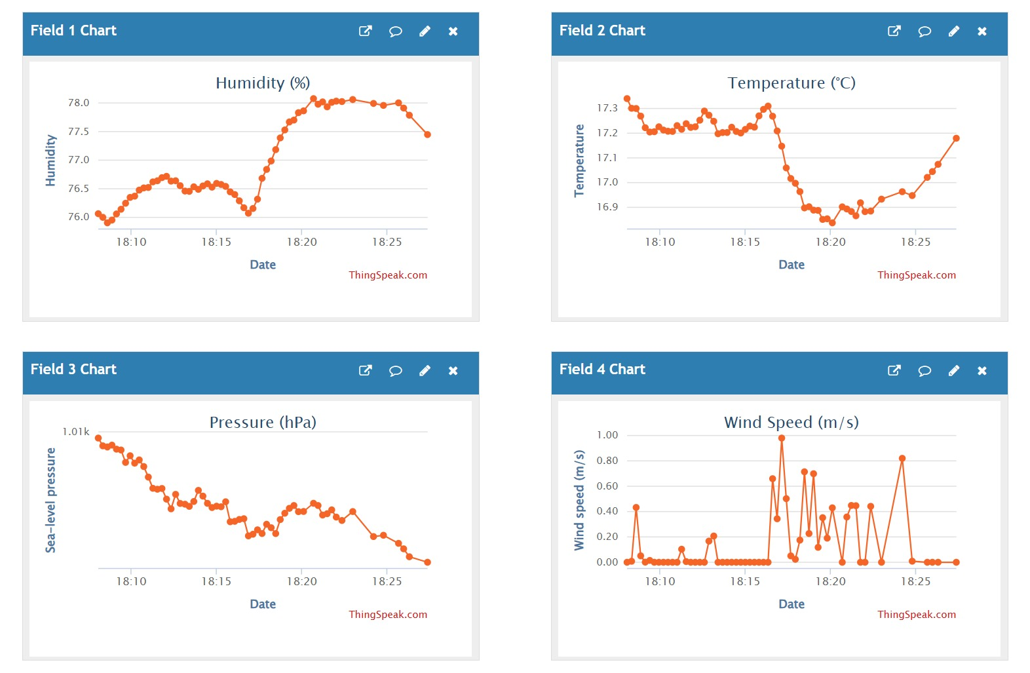
Figure 2. ThingSpeak dashboard during functional testing
The results confirm the functional operation of the prototype as an integrated portable weather station. The system was able to collect meteorological data, transmit them from the portable unit to the central station, and publish them online at 15s intervals during testing. The local OLED display also allowed direct monitoring of the measured values during operation, which is useful during testing and field deployment. Since the evaluation did not include comparison with calibrated reference instruments, numerical accuracy indicators such as measurement error, uncertainty, or deviation from reference values are not reported at this stage.
Several limitations were identified during this stage. First, the wind-speed conversion method has not yet been calibrated against a reference anemometer. The pressure correction also depends on the accuracy of the altitude value used in the firmware. Secondly, the tests focused on functional operation rather than long-term reliability, communication range, battery autonomy, or resistance to severe outdoor conditions. Although the PETG enclosure, plexiglass front panel, silicone gasket, and sealed ingresses provide adequate levels of protection, further improvements would be required before deployment in harsh hurricane-prone island environments, where exposure to extreme weather and infrastructure vulnerability are important concerns (8, 9).

- Conclusions and Future Developments

This paper presented the design, implementation, and functional evaluation of a portable meteorological monitoring system intended for hurricane-prone island environments. The prototype was developed as a low-cost weather station capable of measuring wind speed, temperature, relative humidity, and atmospheric pressure. The system combines an ESP32-based measurement unit, a custom Hall-effect cup anemometer, an AHT20 + BMP280 sensor configuration, wireless transmission through nRF24L01 modules, and an ESP32-based central station connected to ThingSpeak for remote data visualisation.
The functional evaluation confirmed that the prototype can acquire meteorological data, display the values locally, transmit them wirelessly to the central station, and publish them online. These results demonstrate the correct operation of the main data chain, from sensor acquisition to remote visualisation. In this form, the system can be considered a practical complementary tool for local weather observation, especially in areas where permanent meteorological infrastructure is limited, difficult to access, or vulnerable during severe weather events (5, 8, 9).
At the same time, the prototype should not be regarded as a replacement for certified meteorological stations, since the current tests focused on functional operation rather than metrological accuracy, long-term reliability, or performance under extreme environmental conditions (7). In particular, the wind-speed measurement algorithm requires calibration against a reference anemometer, and the temperature, humidity, and pressure readings should be compared with reference instruments.
Future developments will focus on improving measurement performance, mechanical robustness, autonomy, and communication range. The wind-speed measurement system could be improved through a more rigid and better aligned shaft assembly, lower-friction bearings, improved rotor balancing, more precise magnet positioning, and calibration against a reference anemometer. The enclosure could also be improved through better sealing, corrosion-resistant connectors, cable glands, and extended outdoor testing under rain, salt-air, wind, and temperature variations.
The same modular platform could also be adapted for additional sensing applications. Depending on the use case, future versions could integrate air-quality sensors, ultraviolet radiation sensors, rain detection or rainfall measurement, soil-moisture sensors, battery-voltage monitoring, local data storage, or configurable alert thresholds. These extensions would allow the prototype to be used not only for hurricane-related monitoring, but also for broader environmental observation, educational fieldwork, temporary deployments, agricultural monitoring, or community-level situational awareness.
Although the prototype was developed for hurricane-prone island environments, the same communication concept could be extended to other isolated or difficult-to-access locations, such as remote maritime worksites, offshore facilities, natural or artificial islands, temporary field stations, or areas where direct access to main land-based infrastructure is limited. In such scenarios, longer-range radio modules such as SX1278, SX1262, or RFM96, possibly combined with intermediate relay nodes, would be more suitable than the short-range nRF24L01 link used in the current prototype.

Acknowledgements

The author would like to express sincere gratitude to Lecturer Alina Lucia BOȘTINĂ, PhD, for her guidance, support, and valuable feedback during the development of this paper and prototype. The author also thanks Diana-Iuliana MANEA, Lecturer Voicu Nicolae GROȘAN, PhD, and Marin OPREA, PhD, for their technical advice, encouragement, and support during the design, testing, and documentation of the portable weather monitoring system.

Project materials

The firmware, documentation, and 3D-printable parts are available through the project repository: https://github.com/calinemanuelsebastian/portable-hurricane-weather-station.

Bibliography

1. Geiger, T., Frieler, K. and Bresch, D. N. (2018), A global historical data set of tropical cyclone exposure (TCE-DAT), in „Earth System Science Data”, volume 10, issue 1, pp. 185-194, DOI: 10.5194/essd-10-185-2018.
2. World Meteorological Organization (2023), Tropical cyclones and their related hazards, Fact Sheet.
3. National Ocean Service, National Oceanic and Atmospheric Administration (n.d.), What is a hurricane?.
4. National Hurricane Center, National Oceanic and Atmospheric Administration (n.d.), Saffir-Simpson Hurricane Wind Scale.
5. World Meteorological Organization (2018), Multi-hazard Early Warning Systems: A Checklist, Outcome of the first Multi-hazard Early Warning Conference.
6. World Meteorological Organization (n.d.), Global Observing System (GOS).
7. World Meteorological Organization (2024), Guide to Instruments and Methods of Observation (WMO-No. 8), 2024 edition.
8. Mycoo, M., Wairiu, M., Campbell, D., Duvat, V., Golbuu, Y., Maharaj, S., Nalau, J., Nunn, P., Pinnegar, J. and Warrick, O. (2022), Small Islands, in „Climate Change 2022: Impacts, Adaptation and Vulnerability”, Contribution of Working Group II to the Sixth Assessment Report of the Intergovernmental Panel on Climate Change, Cambridge, Cambridge University Press.
9. Pelling, M. and Uitto, J. I. (2001), Small island developing states: natural disaster vulnerability and global change, in „Global Environmental Change Part B: Environmental Hazards”, 3(2), pag. 49-62, DOI: 10.1016/S1464-2867(01)00018-3.
10. Ioannou, K., Karampatzakis, D., Amanatidis, P., Aggelopoulos, V. and Karmiris, I. (2021), Low-cost automatic weather stations in the Internet of Things, in „Information”, 12(4), 146, DOI: 10.3390/info12040146.

